# Lab 9.1 Convert the Countdown application to functions

In this exercise, you’ll change the Countdown application so it uses functions.

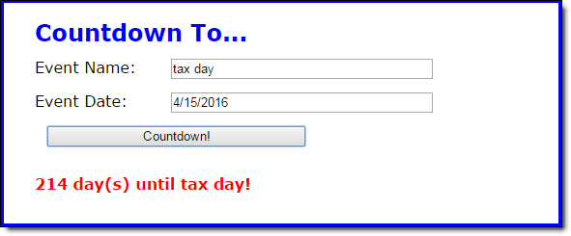

1. Open the HTML and JavaScript files in this folder, run the application and understand how it works.

Note that there are two JavaScript files for this application: the main JavaScript file (countdown.js) and the start of a library file (library_countdown.js).

1. In the countdown.js file, note that three functions are supplied. The $ function. The calculateDays function that contains all of the code for the application. And an onload event handler that attaches the calculateDays function to the click event of the Countdown button and sets the focus on the first field.
2. In the library_countdown.js file, note that two functions are supplied. The clearMessage function clears the message from the node that's passed to it. The hasNoError function returns true or false depending on whether the node that’s passed to it is set to an empty space.
3. In the index.html file, add the script tag for this new library file. Be sure the script tags are in the correct order so the countdown.js file can use the functions in the library_countdown.js file.
4. Add the other functions that are needed for this application to the library file. To do that, move the code from the main JavaScript file to the library and adjust as needed. When you’re finished, the library should include separate functions for

(1) making sure both entries have been made (2 parameters, returns true/false)

(2) testing the validity of just the date entry (1 parameter, returns true/false)

(3) calculating the number of days until the event (1 parameter, returns days)

(4) displaying the number of days until the event (3 parameters, no return value)

Note: Do not use global variables.

1. Modify the countdown.js file so it uses the functions in the library to get the correct results.